WOTS MANUAL TESTING

Here are the results of all manual testing carried out on the WOTS blog site functions based on testing against the projects User Stories.

User Stories:

Story Title: Create a User Account

User Persona: Reader

User Story: As a reader, I want to create a WOTS account so that I can post a comment.

Acceptance Criteria:

- Scenario: User wants to comment on a story about his busness and wishes set the record straight in the comments section.

- Then: User is able to create a user account. Now able to comment on the story about him he believes is incorrect.

Expected Result:
User account will be created using the WOTS Sign Up page.

Actual Result: TEST PASSED ✅
Account “Testdude” created with access using the user account itself and via the Admin backend super user account.

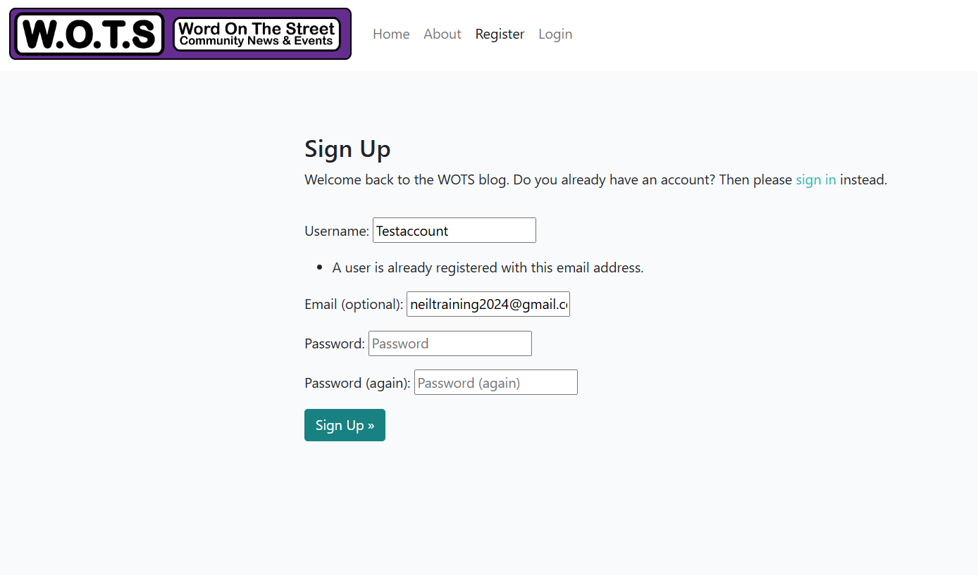
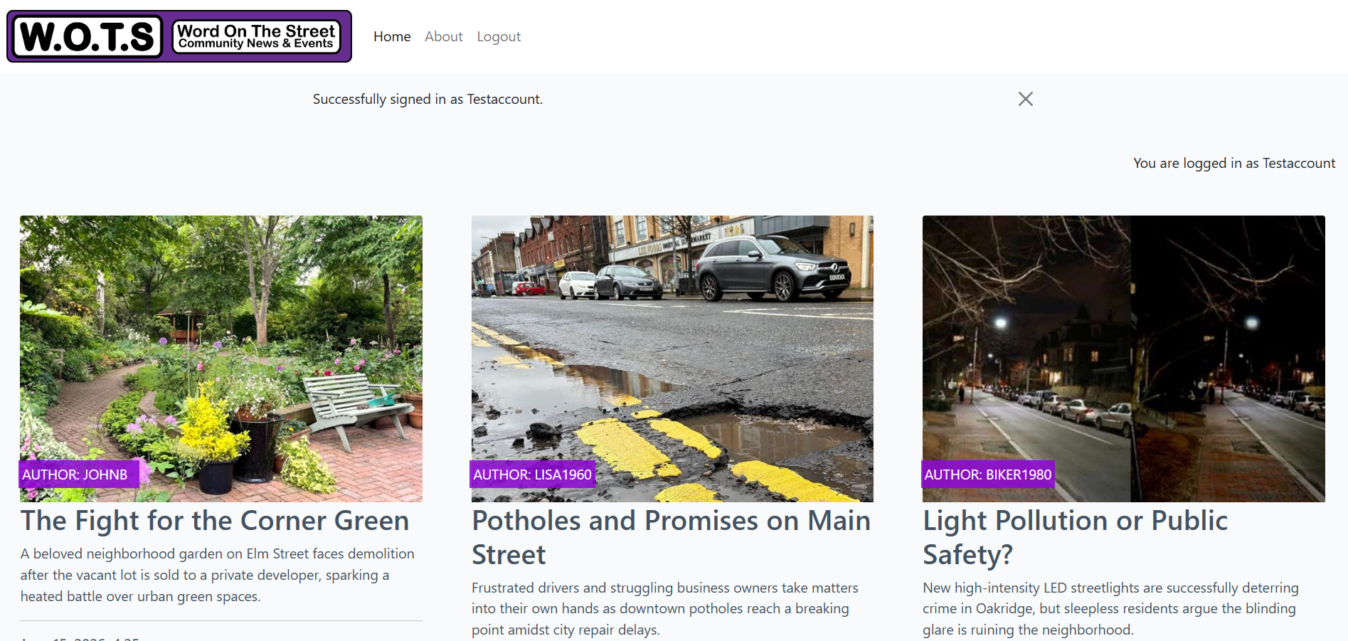

Story Title: Browse & View Articles

User Persona: Reader

User Story: As a reader, I want to be able to browse multiple pages of listed articles before clicking on one to read in detail.

Acceptance Criteria:

- Scenario: User browse for an article on local burglaries

- Then: User finds articles related to burglaries

Expected Result: User will be able to browse through pages of articles

Actual Result: TEST PASSED ✅
User was able to browse through a number of pages until they found the desired article on burglaries that had been affecting their street.
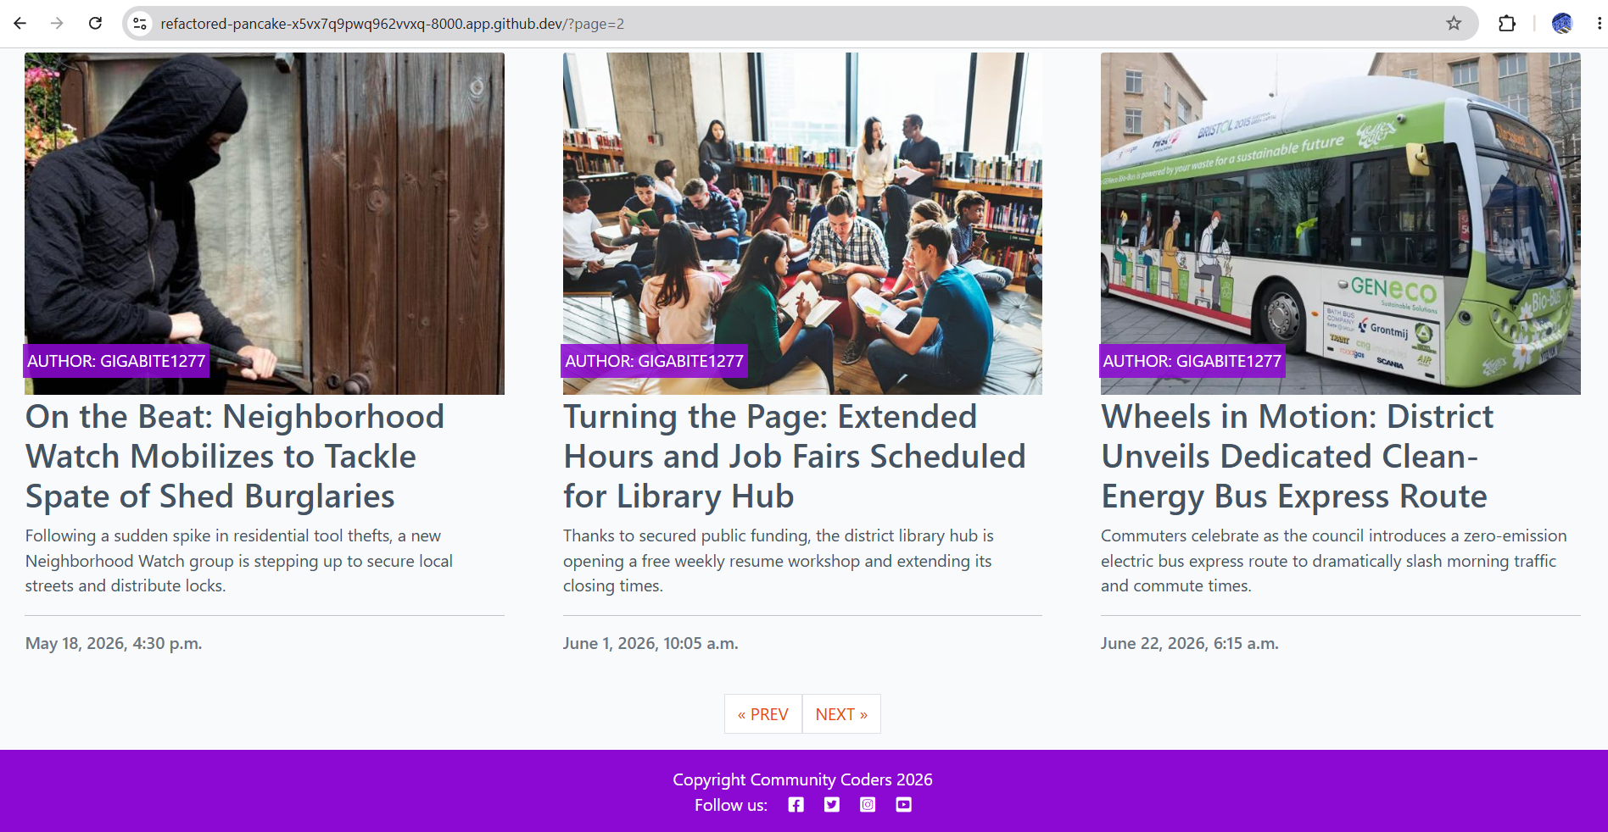

Story Title: Post a Comment

User Persona: Reader

User Story: As a reader, I want to post a comment, regarding a local issues.

Acceptance Criteria:

- Scenario: User wants to post a comment on a road traffic accident that they witnessed on their street.

- Then: User has posted a comment that helped with police enquiries.

Expected Result:
User should be able to set up an account, log in and post the comment on a story.

Actual Result: TEST PASSED ✅
User was able to access an account and post a Neighbourhood watch comment.

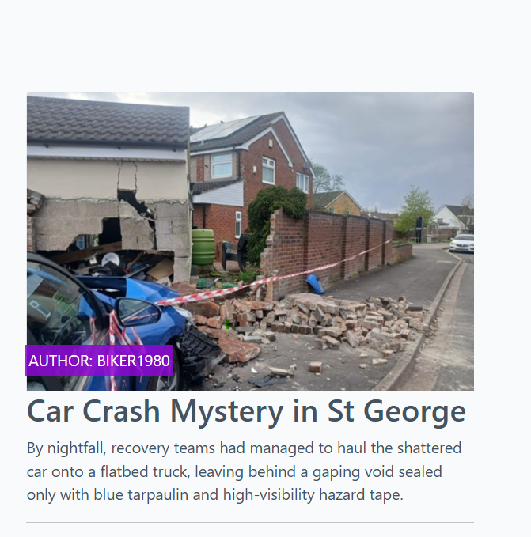

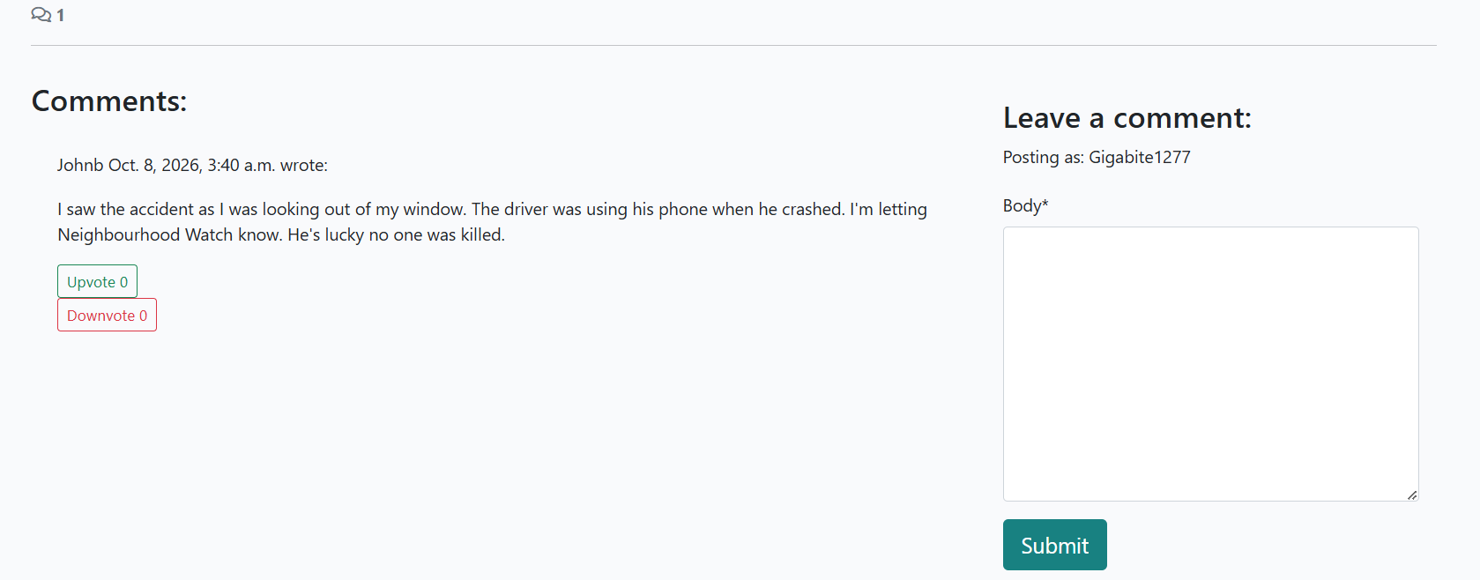

Story Title: Open a News Story

User Persona: Reader

User Story: As a reader, I want to be able to click on a news article, so that I can view the story on a full sized page/screen due to my age and eyesight.

Acceptance Criteria:

Scenario: User hears about the new WOTS and goes online to take a look.

Then: User finds an interesting news article then clicks on it.

Expected Result:
User is able browse pages of articles before selecting and opening one.

Actual Result: TEST PASSED ✅
User was able to access the story and open it up to a large screen for easier reading.

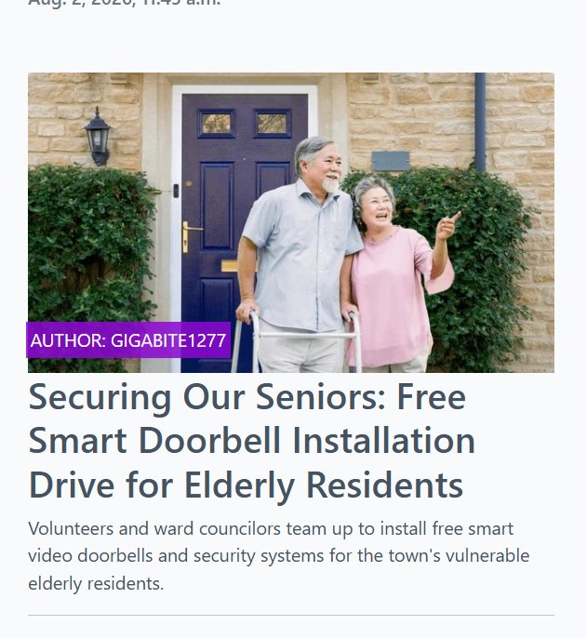

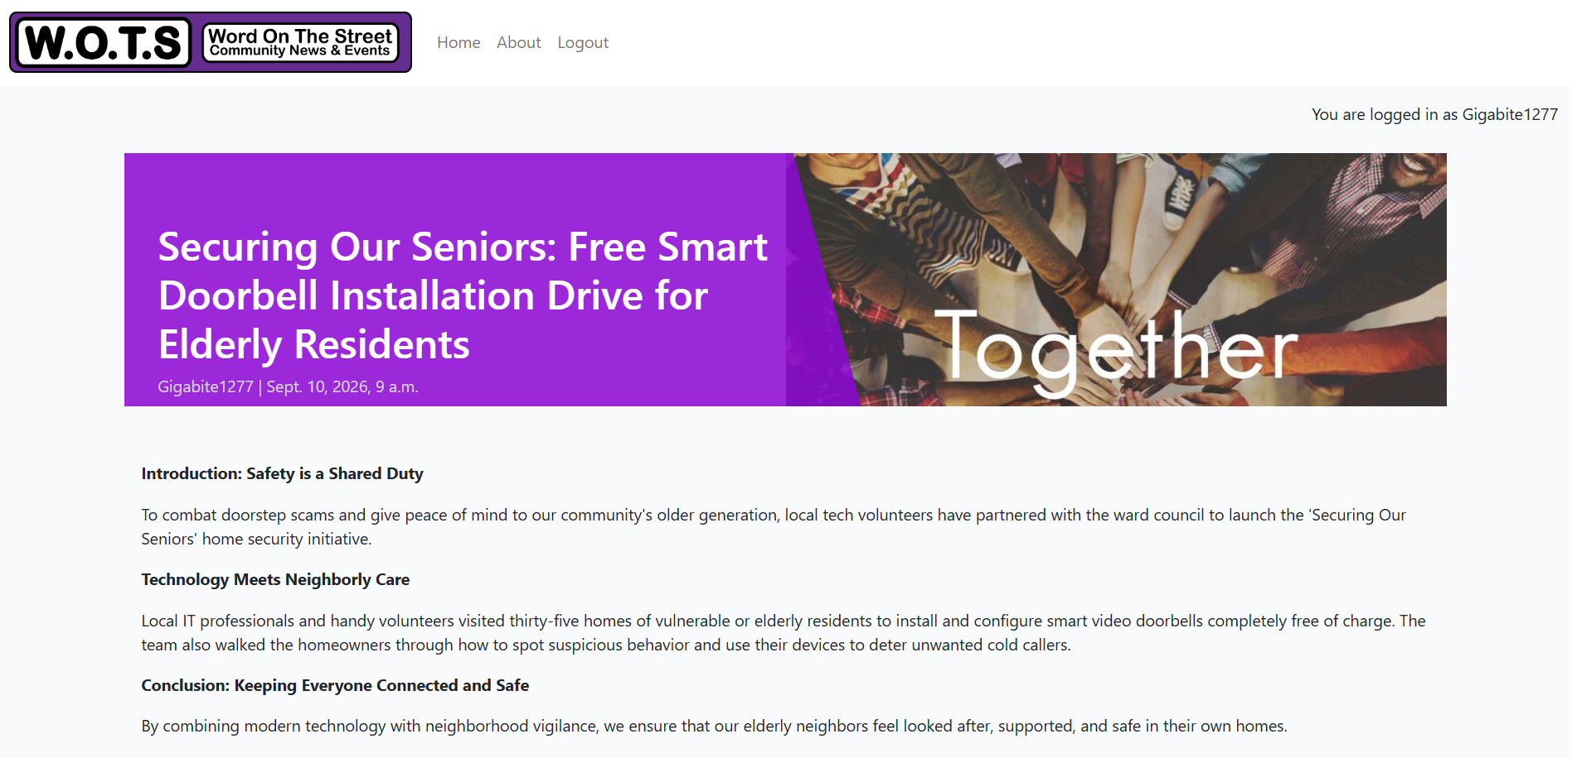

Story Title: Up & Down Comment Rating

User Persona: Reader

User Story: As a reader, I want to be able to rate a comment using the up & down arrow symbol.

Acceptance Criteria:

Scenario: User read an article and was shocked by the top comment.

Then: User was able to vote down the comment using the up or down arrow buttons.

Expected Result:
User is able create and account log in and vote.

Actual Result: TEST PASSED ✅
User was able to create and account locate the article they found offensive and vote down a user’s (stevew) comment that they didn't like.

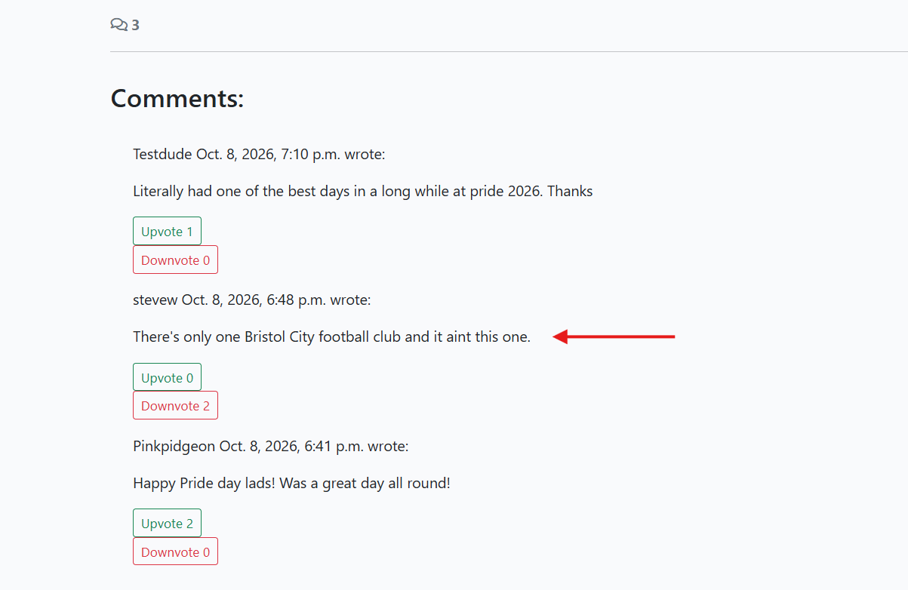

Story Title: Admin Dashboard

User Persona: Admin

User Story: As an admin, I want to use a Django Admin interface, so that I can manage all users, categories, and articles in one place.

Acceptance Criteria:

Scenario: Site admin wants to remove some offensive comments.

Then: Site admin removed homophobic comments.

Expected Result:
Admin is able to remove the user's comment.

Actual Result: TEST PASSED ✅
As the site admin is able to log into the Django Admin Panel and remove the offensive comment, also sending a site usage warning email to the user.

The comment was removed
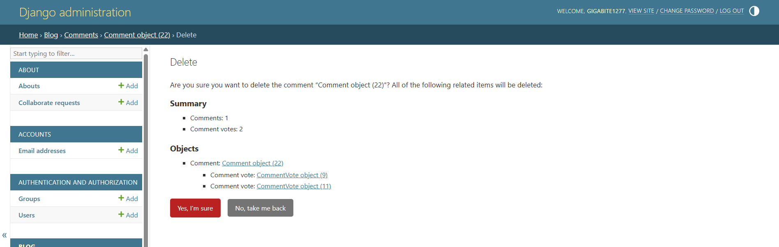
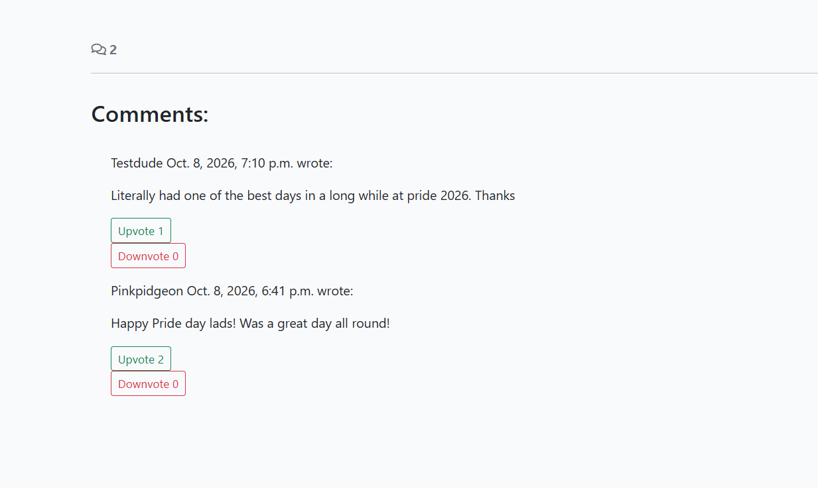

Story Title: Admin Publishing Control

User Persona: Admin

User Story: As an admin, I want to approve and publish drafts submitted by writers to ensure quality control.

Acceptance Criteria:

Scenario: The site has been contacted by the contributor and advised that pet business name provided is incorrect.

Then: Admin pulled the old article and published a new and corrected news article.

Expected Result:
Admin is able to update the article and re-publish it before

Actual Result: TEST PASSED ✅
As the site admin was able to log into the Django Admin Panel and update the article as the contributor has asked.

Pets Paradise was wrongly quoted as helping the family in this article.
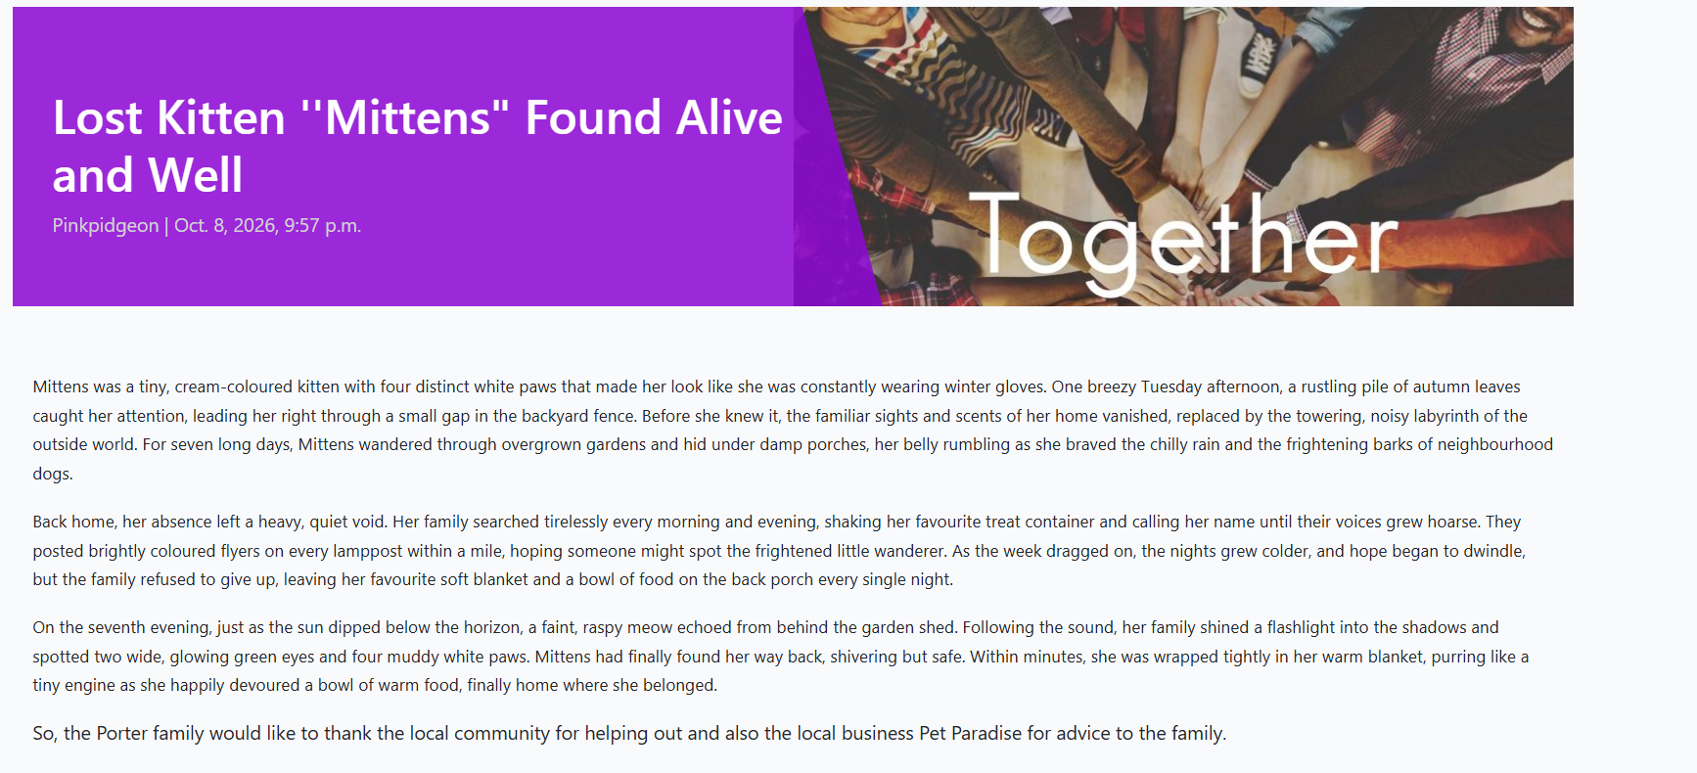

This was swiftly corrected after publishing.

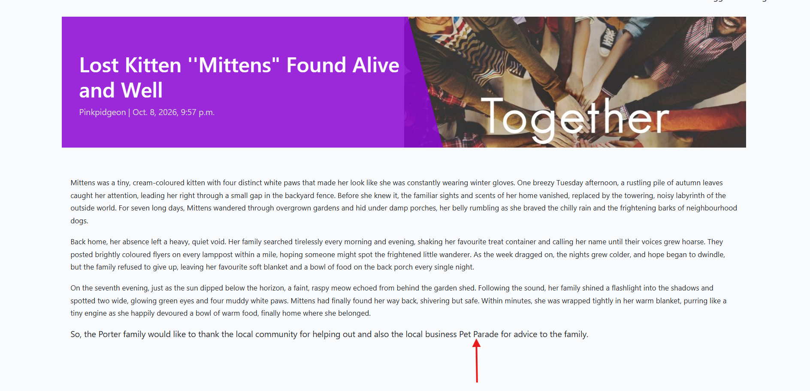

Story Title: The About App

User Persona(s): Reader and Site Admin

User Story (Reader): I want to read an introduction to the blog's superuser/editor and have a way to contact them directly.

User Story(Site Supervisor) I want describe the purpose of the blog site and be able to receive feedback from readers and article contributors.

Acceptance Criteria (Reader):

Then: Local based user comes across the site whilst browsing and is inspired to become a contributor for the benefit of the local community. The user contatcts the site supervisor by using the About form contact form.

Expected Result (Reader):
Readers collaboration request is delivered to site admin Neil Stewart

Actual Result (Reader): TEST PASSED ✅
Collaboration request delivered successfully to site admin Neil Stewart

Acceptance Criteria (Site Admin):

Then: Site Admin receives About contact form messages from a prospective story contributor.

Expected Result (Site Admin):
Readers in the community will use the About app to feedback and collaborate WOTS.

Actual Result (Site Admin): TEST PASSED ✅
First collaboration request successfully received on the WOTS About app.

Reader Alison Davey sends a collaboration request via the WOTS About page.

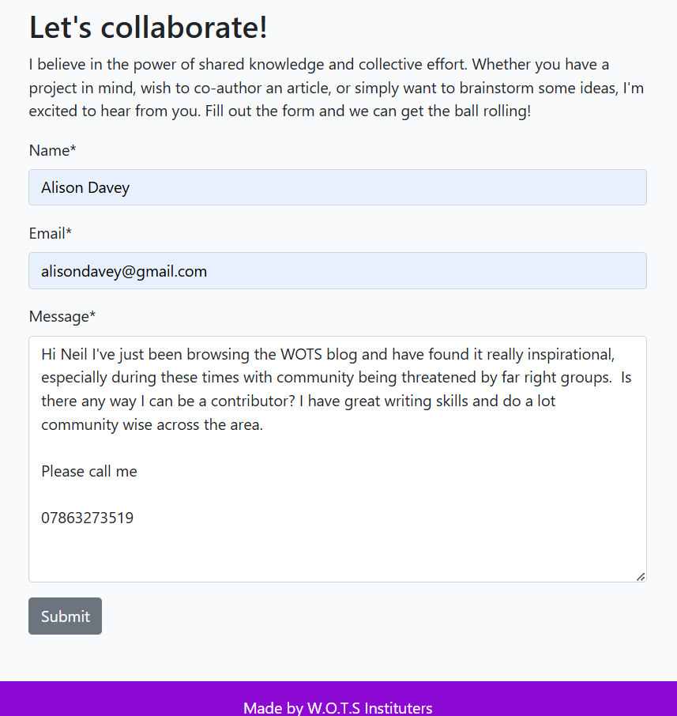

The request is picked up by site admin Neil Stewart.

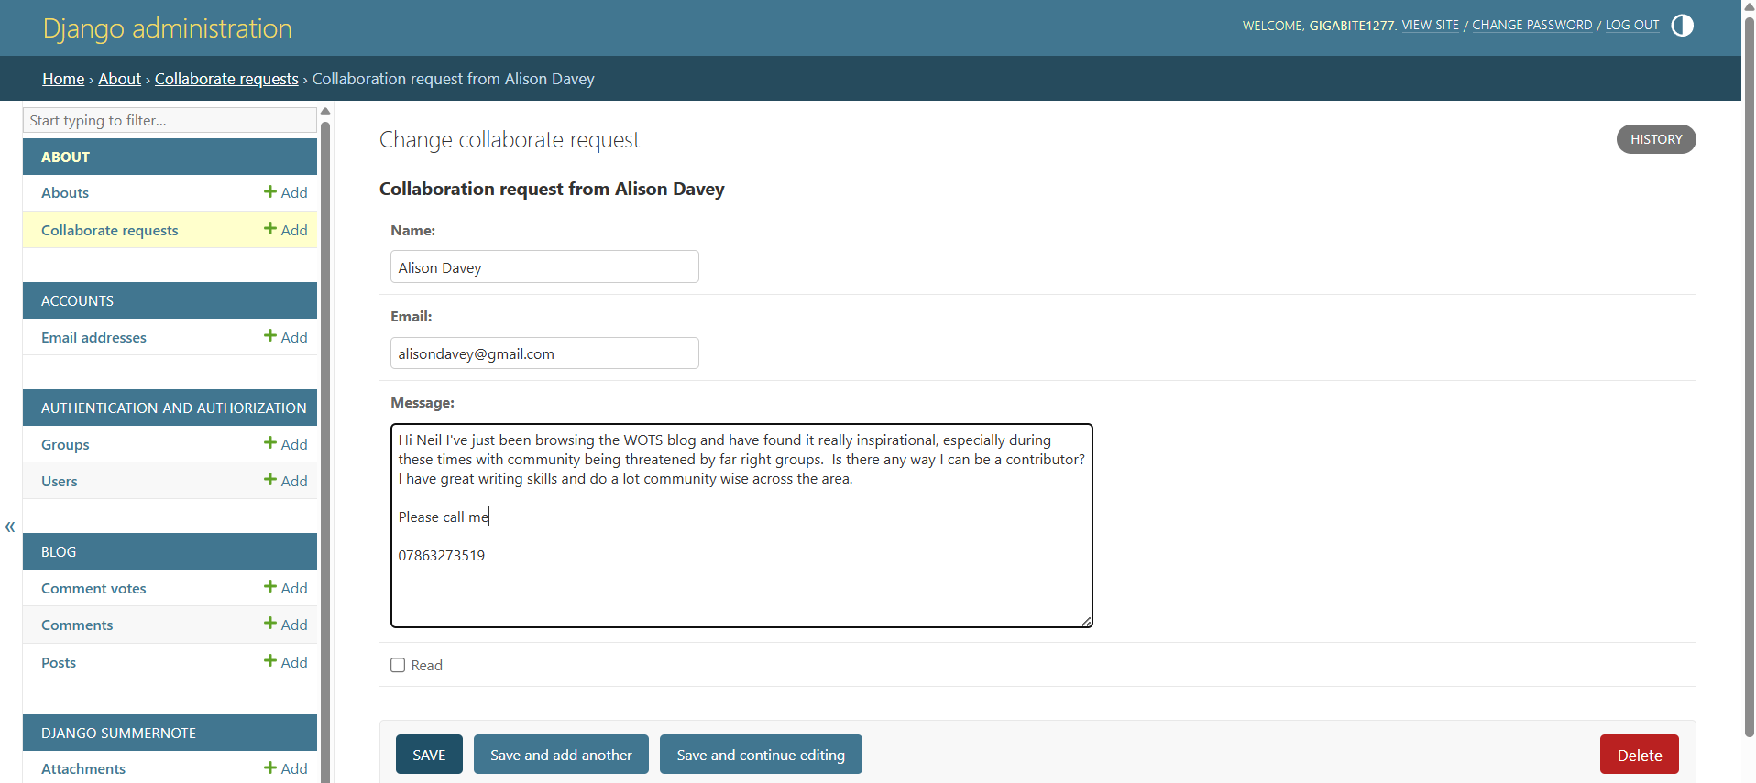

CODE VALIDATION:

W3C HTML validator

About App Templates:
about.HTML: PASSED

Blog App Templates:
index.html PASSED
account_inactive.html PASSED
base.html PASSED
email_change.html PASSED
email_confirm.html PASSED
email.html PASSED
login.html PASSED
logout.html PASSED
password_change.html PASSED
password_reset_done.html PASSED
password_reset_from_key_done.html PASSED
Password_reset_from_key.html PASSED
Password_set.html PASSED
reauthenticate.html PASSED
signup_closed.html PASSED
signup.html PASSED
verification_sent.html PASSED
verified_email_required.html PASSED

Social Account:
Authentication_error.html PASSED
Base.html PASSED
Connections.html PASSED
Login_cancelled.html PASSED
Login.html PASSED
Login.html PASSED
Signup.html PASSED
Test_403_csrf.html PASSED
Base.html PASSED

CI Python Linter
https://pep8ci.herokuapp.com/

Python.py Files

About App:
Migrations Folder PASSED
admin.py PASSED
apps.py PASSED
forms.py PASSED
models.py PASSED
urls.py PASSED
views.py PASSED

Blog App:
Migrations Folder PASSED
admin.py PASSED
apps.py PASSED
forms.py PASSED
models.py PASSED
urls.py PASSED
views.py PASSED

WOTS:
_init_.py N/A
asgipy PASSED
settings.py PASSED
urls.py PASSED
wsgi.py PASSED

ROOT FOLDER:
manage.py PASSED

CSS Files:
W3C CSS Validator results for TextArea (CSS level 3 + SVG)
Static Folder:
Style.css PASSED

Staticfiles Folder:
Style.css PASSED

